Origami

User Guide

|  |  |  |
| --- | --- | --- |
| **Supervisor** | Miss Iqra | |
| **Batch** | 2109d | |
| **Group** | Origami | |
| **Serial No.** | **Enrollment Number** | **Student Name** |
| **1.** | Student1334852 | Owais |
| **2.** | Student1335136 | Muneeb |
| **3.** | Student1336743 | Munir |

USER GUIDE

“Pages and Fold” This Website is basically based on Origami and how to make it. If you are passionate about Origami, so just this website made for you.

**1. Top Layout:**

This is the Top of the page.

* + User can know about the website by clicking on About Us button
  + Users can get touch to the admin by Login their selves from this page.



**2.Home Page:**

* + This page contain our special Origami and their detail.

OUR SPECIALITIES:



OUR GALLRY:

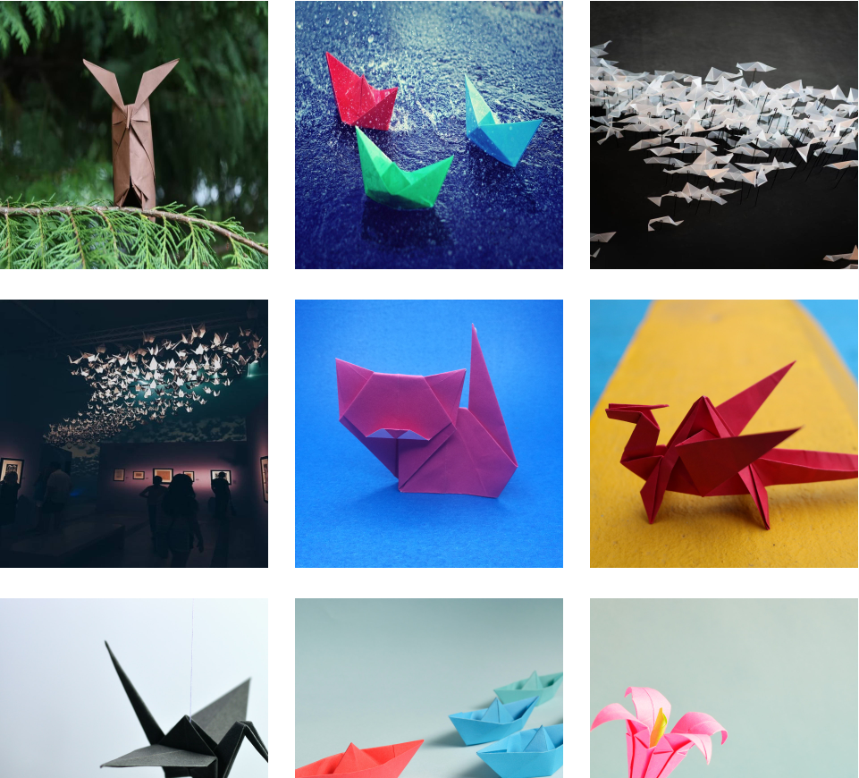

**3.Contact Page:**

This is the Contact Page.

* In this page users can get in touch with us.
* They can leave their comment.

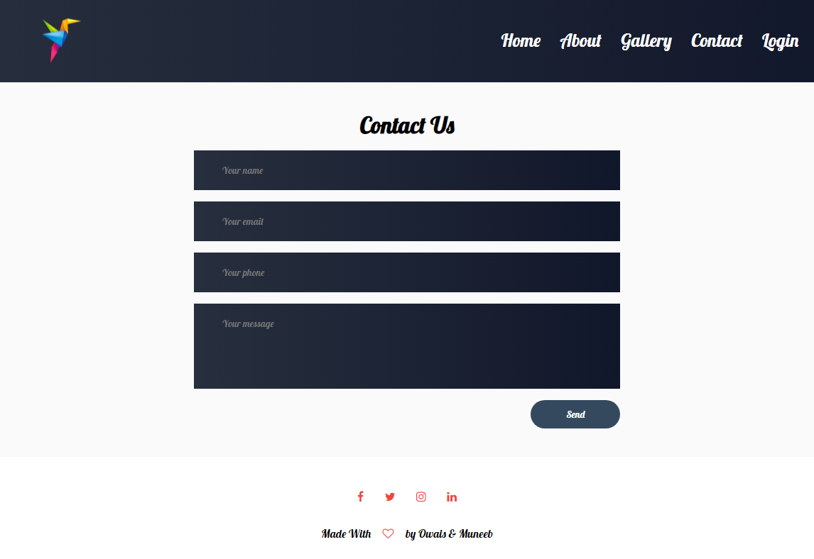

**3.About Page:**

This is the About Us Page.

* This page has some Information about our shop.

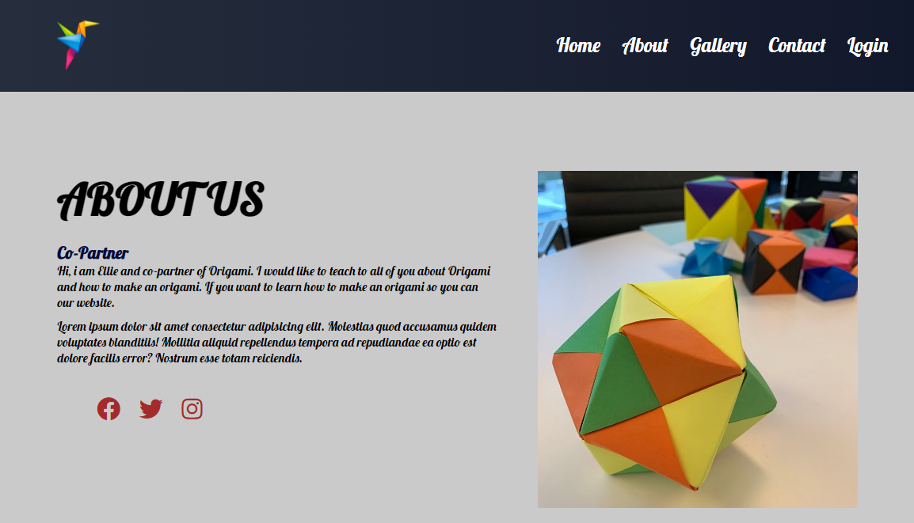

**4. Bottom Layout**

This is the Bottom of the page.

* It has some Links like Shop Page , Contact Page and Our Specialties.
* It has some Popular Recipes link as well as some Official Pages links

